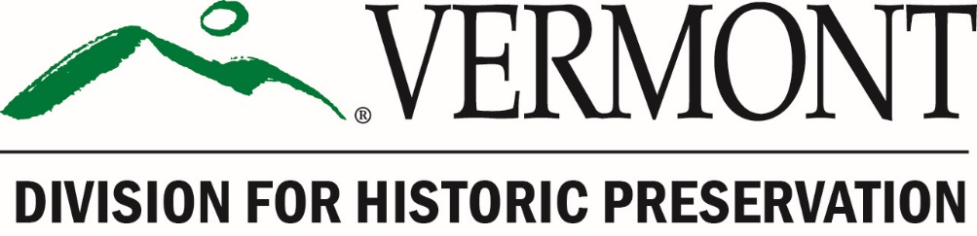

Vermont

Certified Local Government Program

2026 Grant Application

FFY 2026 grant funding provided by the

National Park Service Historic Preservation Fund

Grant Period: April 23, 2026 – September 30, 2028

Vermont Certified Local Government Program

2026 Grant Application

Application Deadline: On or before 4:30 PM, Monday, March 16, 2026.

What to Submit: All application materials must be submitted prior to the application deadline. A complete application consists of the following items, in the following electronic formats:
☐ Application Form, signed by the applicant, the Chair of the CLG Commission, and the Chief Elected Local Official (or designee). Submit PDF of the complete application with all signatures, e-signed or scanned signature page.
☐ Proposed Budget Form, signed by the Chief Elected Local Official (or designee). Submit the following:
☐ a scanned PDF of the signed Proposed Budget Form
☐ an MS Excel version of the Proposed Budget Form.
☐ Any supporting materials, such as photographs, maps, reports, assessments, etc. that support and inform the proposed project. Submit these materials as PDFs.

How to Submit the Application:
Please submit all the above items as attachments to an email, identified as follows:
Email Subject Line: [Name of CLG Community] – 2026 CLG Grant Application
Attachments: [Name of CLG Community] – Application Form (PDF)
[Name of CLG Community] – Proposed Budget Form (PDF&Excel)
[Name of CLG Community] – Supporting Materials (PDF)

Where to Submit: All application materials should be submitted electronically via email to Lindsay.Pacheco@vermont.gov

If you have any questions about the application process, please contact
Elizabeth Peebles at 802-505-1147 or elizabeth.peebles@vermont.gov

Vermont Certified Local Government Program

2026 Grant Application Form

Project Name: Click or tap here to enter text.

Name of CLG Community: Click or tap here to enter text.
Name of CLG Coordinator: Click or tap here to enter text.
Telephone: Click or tap here to enter text.
Email: Click or tap here to enter text.
Mailing Address: Click or tap here to enter text.
Name of Municipal Treasurer:
Telephone: Click or tap here to enter text.
Email: Click or tap here to enter text.

Will this project be administered by a designated third party? ☐Yes or ☐ No
If yes, name of organization: Click or tap here to enter text.
Name of Project Coordinator: Click or tap here to enter text.
Telephone: Click or tap here to enter text.
Email: Click or tap here to enter text.

Project Category:
Please check the appropriate category below.

Priority I Projects
☐ Survey Project.
Please describe in Project Summary:
- purpose of the project;
- area to be surveyed (include map);
- estimated number of properties to be surveyed;
- estimated number of acres to be surveyed;
- survey methodology;
- status of historic survey in the CLG community.

☐ National Register Project.
Please describe in Project Summary:
- purpose of the project;
- individual resource or historic district to be nominated (include map);
- property type or theme for Multiple Property nomination;
- survey the nomination is based on;
- for a historic district, the estimated number of resources within the district;
- status of historic survey in the CLG community;
- status of National Register nominations in the CLG community.

☐ Preservation Planning Project.
Please describe in Project Summary:
- purpose of the project;
- area to be covered by the plan (include map);
- status of preservation guidance and regulation in municipal plans and bylaws;
- status of historic survey in the CLG community;
- status of National Register nominations in the CLG community.

☐ Information and Education Project.
Please describe in Project Summary:
- purpose of the project;
- audience, methods, and products;
- status of historic survey in the CLG community;
- status of National Register nominations in the CLG community;
- status of preservation guidance and regulation in municipal plans and bylaws.

☐ Pre-development Project.
Please describe in Project Summary:
- purpose of the project;
- property or area of study/development (include map);
- scope of work and products;
- status of historic survey in the CLG community;
- status of National Register nominations in the CLG community;
- status of preservation guidance and regulation in municipal plans and bylaws.

Priority II Projects
☐ Development Project.
Please describe in Project Summary:
- purpose of the project;
- property or area of development (include map);
- scope of work and products;
- status of historic survey in the CLG community;
- status of National Register nominations in the CLG community;
- status of preservation guidance and regulation in municipal plans and bylaws.

Project Summary:
(provide an overview of the project and address the items noted in the Project Category selected above)
Click or tap here to enter text.

Please Answer the Following Questions:
- How will the public be informed about the purpose of this project and the value of historic preservation?
(note: public information and education is required of all CLG grant projects)
Click or tap here to enter text.

- Describe the impact that this project will have on historic resources. Will it be significant and long lasting?
Click or tap here to enter text.

- Does this project support disaster preparation, mitigation, and resilience?
☐ Yes -or- ☐ No
If yes, please describe how:
Click or tap here to enter text.

- Describe the types of historic resources that are in the project area/study focus, both known and anticipated.
Click or tap here to enter text.

- Will the project involve a National Historic Landmark?
☐ Yes -or- ☐ No

- Will the project involve any ground disturbance?
☐ Yes -or- ☐ No
If yes, please describe the nature of the disturbance (sign post hole, monitoring well, archaeological testing, trenches etc) and include a map showing any areas of possible ground disturbance. Identify on the map any known historic resources such as buildings, stone walls, wells, foundation ruins etc.
Click or tap here to enter text.

- List project schedule assuming starting date of June 2026 and completion date of August 1, 2028. List dates for subcontracting with consultants, on-site meetings, delivery of draft products, such as survey and National Register forms, and public meetings, as applicable. All products, including a final project report and auditable financial documentation, are due by the completion date.

DATE | Task/Product Competed
4/23/2026 | SHPO notifies applicants of grant awards
~ 6/2026 | Executed Grant Agreement
12/1/2026 | First Progress Report Due
6/1/2027 | Second Progress Report Due
12/1/2027 | Third Progress Report Due
6/1/2028 | Fourth Progress Report Due (projects substantially completed)
8/1/2028 | Completion Deadline: Submit final project report, final product, and request reimbursement. Extensions are not available.
9/30/2028 | Deadline for SHPO to process payment requests and disburse grant funds.

- Who will participate in the project and what will they do? Describe the personnel listed in the budget (CLG staff and commissioners, consultants, volunteers) to their role in completing the project.
Click or tap here to enter text.

- What are the dates of the local government’s fiscal year?
Click or tap here to enter text. to Click or tap here to enter text.

Designated Third Party
(complete this section only if applicable)
- Third-Party fiscal year:
Click or tap here to enter text. to Click or tap here to enter text.

- Describe the Third Party’s experience with federal grants:
Click or tap here to enter text.

- Third Party’s accounting system:
☐ Manual ☐ Automated ☐ Combination

Signatures:
This application is not complete until all required signatures are entered below.

Click or tap here to enter text. Click or tap here to enter text.
Name of person preparing this application Title

___________________________________________________________________
Signature Date

Click or tap here to enter text.
Name of CLG Commission Chair

___________________________________________________________________
Signature Date

Click or tap here to enter text. Click or tap here to enter text.
Name of Chief Elected Local Official (or Designee) Title

___________________________________________________________________
Signature Date

(if applicable)
Click or tap here to enter text. Click or tap here to enter text.
Name of Third Party Administrator Title

___________________________________________________________________
Signature Date

